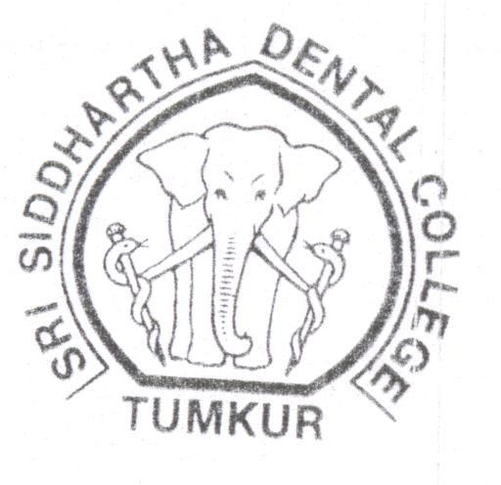

Space for

Photo

Application

Number

________________

Admission

Number

________________

Roll Number

Phone: 0816-2278867

0816-2275536

**Sri Siddhartha Dental College**

**Agalakote, Tumkur Dist**., Karnataka (India)

**(Affiliated to Sri Siddhartha Academy of Higher Education, Sri Siddhartha University)**

**Deemed to be University under UGC Act 1956.**

**Application for Admission of the Post-Graduate Degree**

|  |  |
| --- | --- |
| 1. Name of the Candidate   (Block letters) --- | Mr./Miss. |
| 1. Father’s Name ---   a) Qualification ---  b) Occupation ---  c) Present Address --- |  |
| 1. Name of the guardian and relationship   If the father is not alive  a) Qualification ---  b) Occupation ---  c) Present Address --- |  |
| 1. Permanent address of the candidate   (Block letters) ---  Phone No. |  |
| 1. i) Permanent address of the father or   guardian  (Block letters) ---  Phone No. |  |
| ii) Local Address  (Block letters) ---  Phone No. |  |
| 1. Telegraphic address of Candidate and father/guardian as well as telephone number, if any --- |  |

(P.T.O)

2

|  |  |
| --- | --- |
| 1. a) Nationally ---   b) Religion ---  c) Caste ---  d) Sub-Caste ---  Passport No. --- |  |
| 1. Annual Income of father / guardian ---- |  |
| 1. i) Date of Birth (in Christian era) ---   ii) Place of birth (Here enter place,  Taluk and District) ---  iii) State of domicile ---  iv) Mother tongue ---  v) Languages which you can read,  write and speak --- |  |
| 1. a) Name and address of two responsible   persons who can vouch for the  candidates Character ---  b) Name and address of the principal  of the Institution where he/she  studied last --- |  |
| 1. Name of near relative, if any who   Have been Doctors --- |  |
| 1. Educational Qualification:   BDS Degree Name of the College & Uni.,   1. Name of the qualifying Examination   Passed  BDS Degree/P.G Diploma in the  Particular subjects (if any)   1. Reg. No. month and year of   Passing:  BDS/P.G Diploma where applicable   1. Name of University/Board --- 2. State --- |  |
| 1. Marks cards of: BDS Degree   Examinations/semester/Annual (Attach copies of marks cards obtained or university examinations since admission to BDS Course) |  |

P.T.O

3

B.D.S. Degree Examination:

College :

University :

State :

Year of Passing :

|  |  |  |  |  |  |
| --- | --- | --- | --- | --- | --- |
| **Name of Examination** | **Max**  **Marks** | **Min**  **Marks** | **Marks**  **Obtained** | **Percentage** | **No. of**  **Attempts** |
| **I BDS**  1 Human Anatomy  2 Physiology & Bio-Chemistry  3 Dental Materials |  |  |  |  |  |
| **II BDS**  1 Gen.Pathology & Microbiology  2 Gen-Dental Pharmacology  3.D.A.O.H  4 Pre-clinical Operative Dentistry  5 Pre-Clinical Prostho Dentistry |  |  |  |  |  |
| **III BDS**  1 Gen-Medicine  2 Gen-Surgery  3 Oral Pathology & Microbiology  4. Community Dentistry |  |  |  |  |  |
| **Final BDS**  1 Oral Medicine & Radiology  2 Orthodontics  3 Pedodontics  4 Prosthodontics & Crown & Bridge  5 Conservative Dentistry & Endodontic  6 Oral & Maxillofacial Surgery  7 Periodontics |  |  |  |  |  |

(P.T.O)

4

**DECLARATION BY THE CANDIDATE**

I wish to apply for admission to Sri Siddhartha Dental College and declare that I have filled this form myself and to the best of my knowledge and belief, the above particulars are true.

I have gone through instructions for admission carefully and undertake to abide by all conditions. I further agree, if admitted to conform to the rules and regulations at present in force or that may hereafter be made for the administration of the College and Hostel.

**HOSTEL STUDENTS**

**RULES TO BE STRICTLY FOLLOWED BY THE CANDIDATES SEEKING ADMISSIONS.**

1. **HOSTELLERS** : If a students he or she misbehaves with the management becomes a defaulter for more than a month, refuses to follow the rules imposed by the Management from time to time. He/she shall be dismissed from the Hostel unconditionally. He/She shall take prior permission from authority (Warden Management) while going out of Hostel other than class hours. While than going out of Hostel other than class hours, the movement Register shall be signed by the candidate. Hosteller are not allowed to keep themselves away from the Hostel for more than 8 (eight) hours continuously without prior permission from the Authority. Two wheelers four wheelers are not allowed in the Hostel/College/Hospital Campus.

Note: Visitors to the Hostel shall take the permission from the concerned authority to visit the Hostels(applicable to the both Boys and Girl’s Hostels).

Place:

Date:

**Candidate’s Signature**

**DECLARATION BY THE PARENT/GUARDIAN**

I hereby declare that I have known the financial obligation and I can afford to pay all the costs and undertake to pay the tuition and other fees payable to the Institution under the rules framed from time to time by the Management of the College.

Place:

Date: **Signature of the Parent/Guardian**

**Are the following attested copies of certificates enclosed Yes/No**

1. Marks card of qualifying Examination …………..
2. Transfer Certificate from the Institution last attended …………..
3. Migration Certificate from the Board/University …………..
4. Character / Conduct Certificate from Institution …………..
5. Certificate in proof of Date of Birth …………..
6. Eligibility Certificate from the Sri Siddhartha University …………..
7. Clearance Certificate from New Delhi …………..

(Ministry of Health & Family-Welfare)

1. Student Visa ……………
2. Passport copy ……………
3. Residential Certificate …………..
4. Any Other Certificate …………..

(Item No. 6,7,8,9 & 10 apply to Foreign student only)

**Note:** Originals of the above shall be delivered at the time of

admission without which the Provisional admission is not complete.                                                                                                                 **Signature of the Principal/Director**